Straw Towers

| **Subject:**  **Related Subjects:** | **Grade Level(s):** 4  **Length of Lesson:** 90 Minutes | **Type:** Inquiry / Design / Project  **Keywords**:Structure, Build, Force, Load |
| --- | --- | --- |

# Lesson Overview

The "Tall Tower Challenge" activity explores the design of tall structures such as skyscrapers and telecommunication towers. Students work in teams to engineer the tallest tower they can build using just straws, pipe cleaners, and paperclips. The tower must be strong enough to support the weight of a golf ball for two minutes.

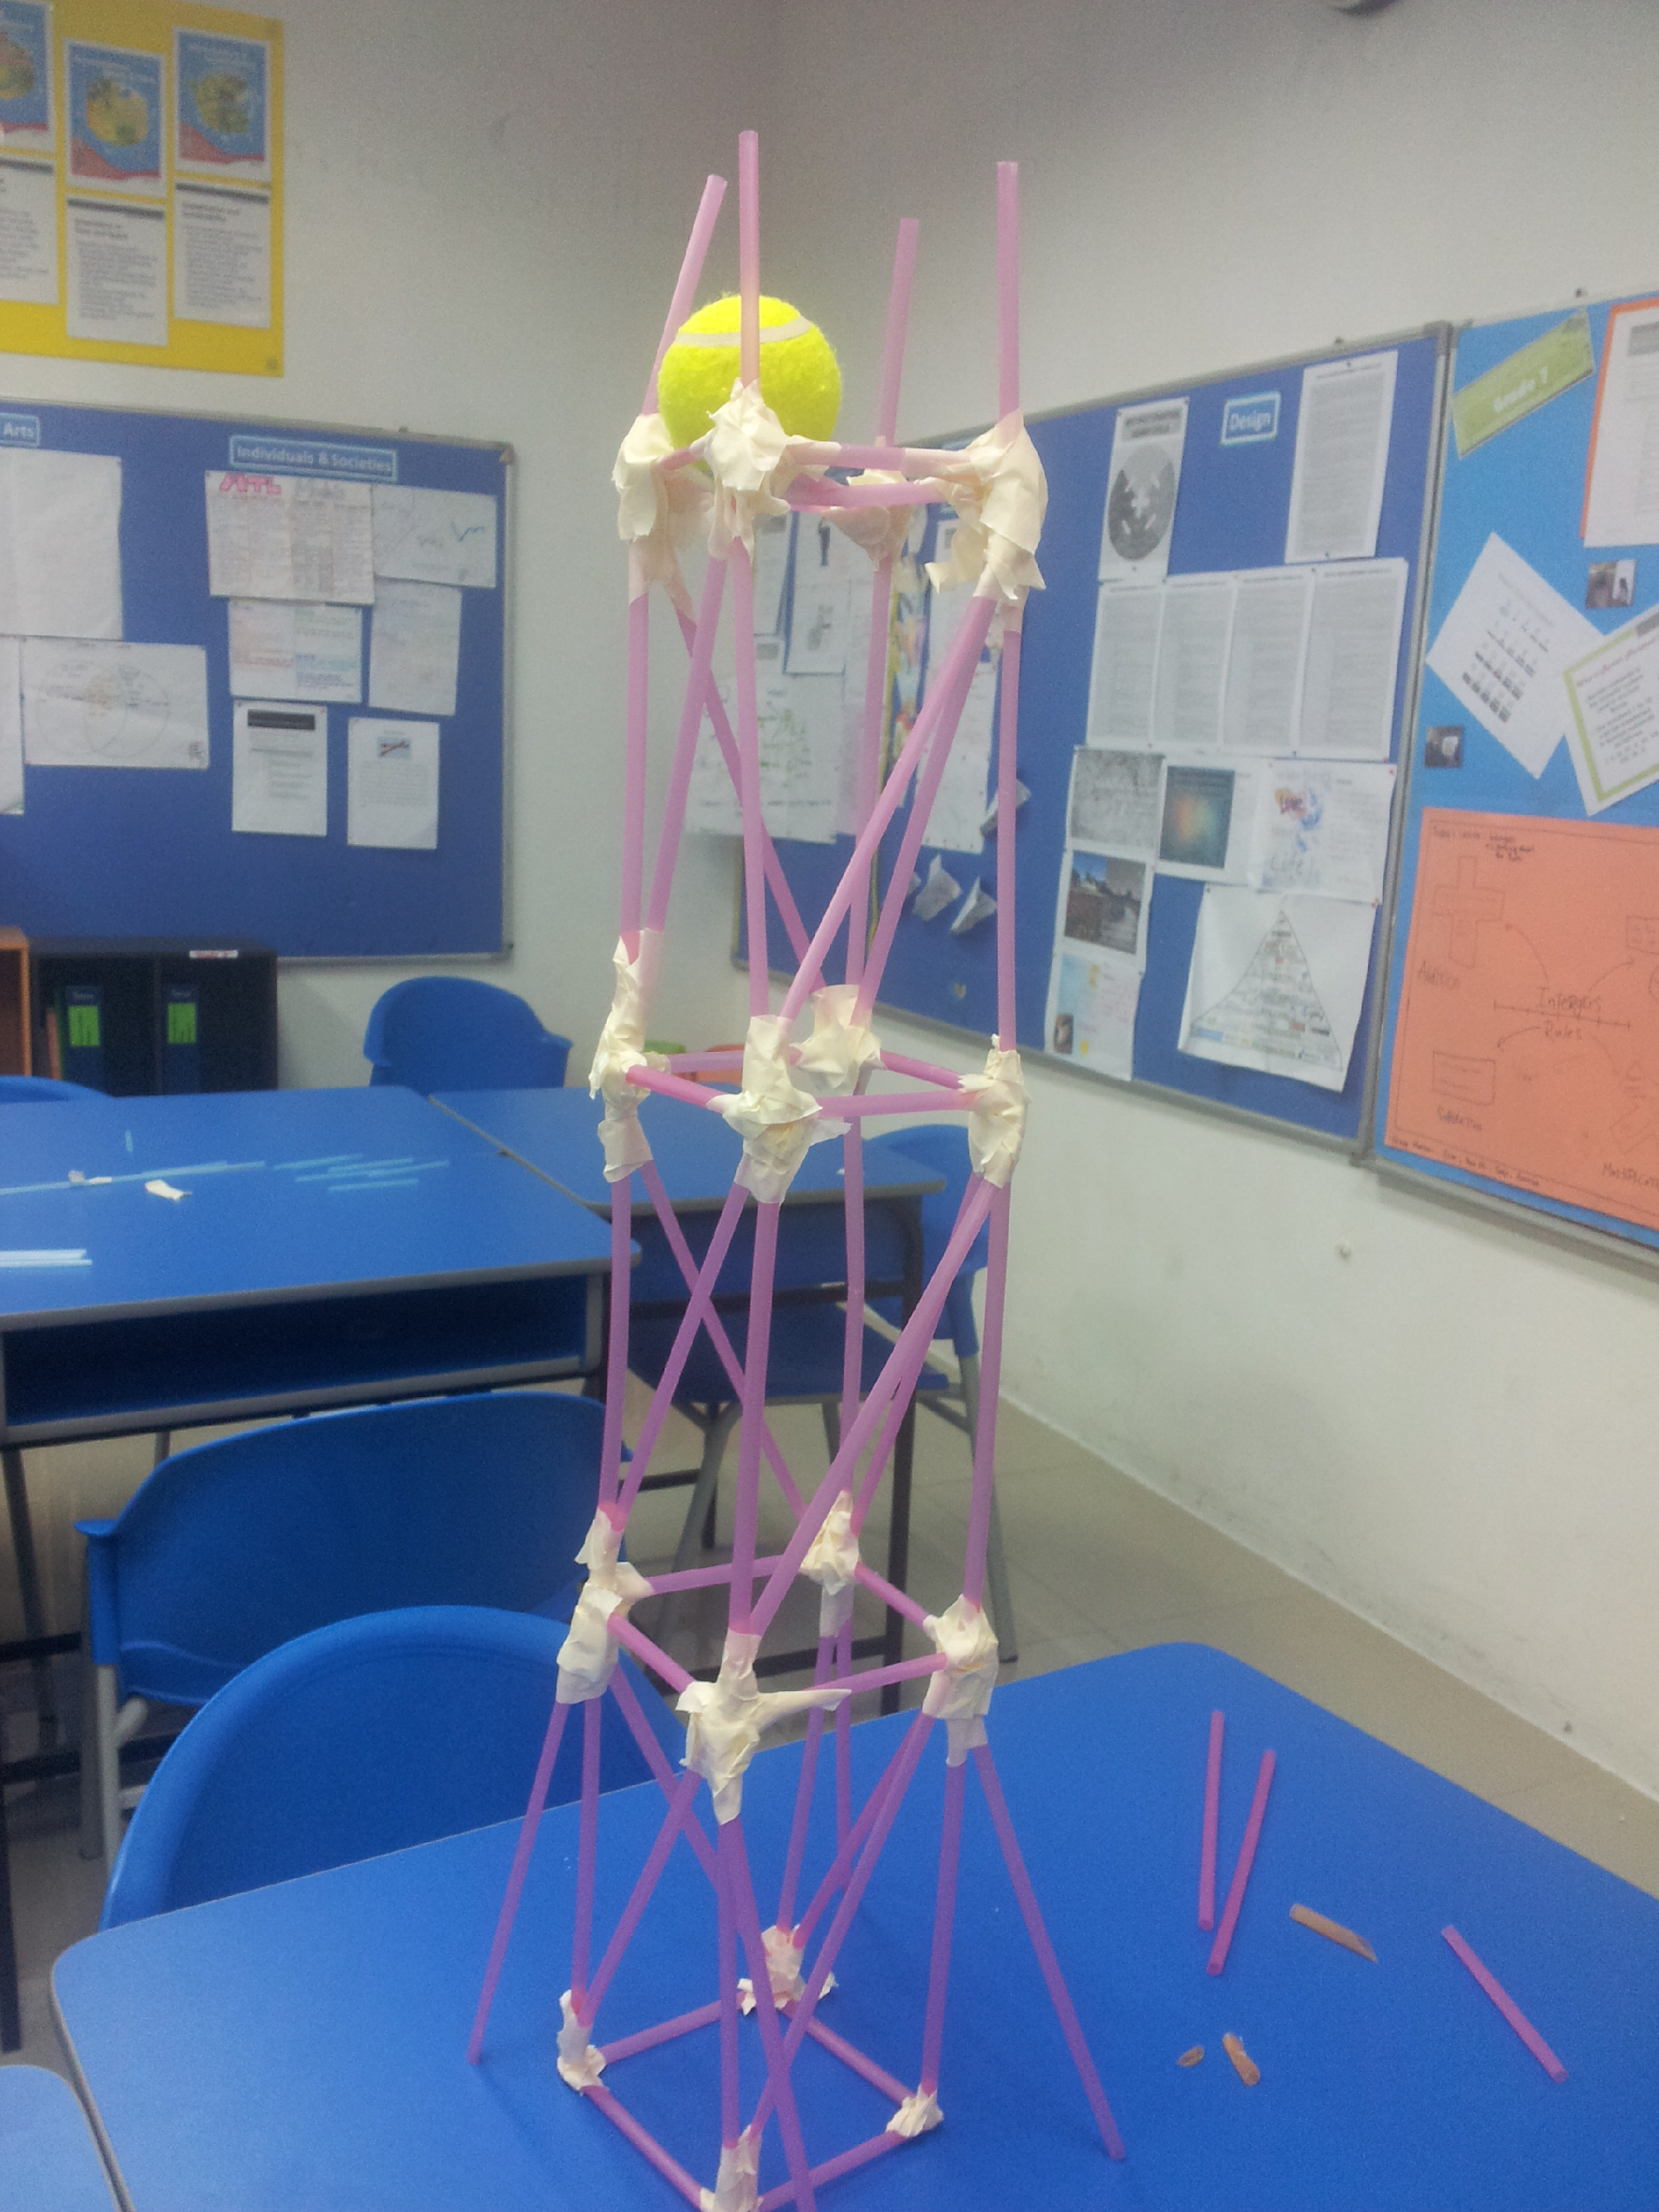

# Lesson Focus

*What is the central question or phenomenon being investigated? What problem are they trying to solve?*

| Lesson Objective(s) | * Learn about structural engineering. * Learn about engineering design and redesign. * Learn how engineering can help solve society's challenges. * Learn about teamwork and problem solving. |
| --- | --- |

# Lesson Timing

# 

| Time | Description |
| --- | --- |
| 2:30-2:45 | Introduce the Lesson   1. Review key lessons from last week 2. Discuss our plans for the day 3. Ask Pre-Lesson Questions 4. Go Over Vocab |
| 2:45-2:50 | Person of Color |
| 2:50-3:40 | Lesson |
| 3:40-3:50 | Lesson Wrap Up & Assessment |
| 3:50-4:00 | Lesson Cleanup |

| Materials | * Plastic straws (20 per student) * Rubber ball as weight * Masking tape * Scissors |
| --- | --- |
| Instructor Prep | 1. Step 1 |
| Related Resources | * List related lessons/ppts etc available from USC or outside, trusted orgs |

# Lesson Plan

## Introduction

1. What do engineers do?
   1. Use math and science to develop products
   2. Work on the development of buildings and bridges
   3. Create new products based on mathematical and scientific ideas
2. What makes a structure safe?
   1. A solid base
   2. Good Reinforcement
   3. Use of appropriate materials
3. How can teams be more effective than individuals?
   1. More people involved with more ideas
   2. Team mates can challenge each other to improve
   3. Less effective ideas can be caught by team mates

## Procedure

1. To introduce the lesson, discuss with students the increase in the height of buildings over the last century. Perhaps consider what the highest building in your community might be, and compare that with some of the tallest buildings in the world.
2. Present the challenge to the kids: build the tallest and sturdiest tower you can using the materials provided.
3. Teams will consider their challenge and draw a diagram of their planned tower on paper.
4. Students are given their supplies and construct their towers. It is okay for them to deviate from their original designs as long as they have a clear purpose for doing so.
5. All students then present their towers to the class and demonstrate the ability of the tower to hold the rubber ball.
6. All towers are measured to determine the tallest tower.
7. Student teams reflect and share their experiences with the class.

## Wrap-up

1. Does the size of the height of the tower affect how much hold weight it can hold?
2. Does the shape (width) of the tower affect how much weight it can hold?
3. Which shape is the strongest? Triangle Square
4. What shape is most commonly used for reinforcement?
   1. Triangle
5. What is the most common shape for a base?
   1. Rectangle/square
6. Why is some flexibility good in a structure?
   1. Because this can prevent an earthquake from destroying it

The purpose of the survey is to let us know your opinions about today’s project. Remember there are no right or wrong answers.

|  |  | Strongly Disagree | Disagree | Undecided | Agree | Strongly Agree |
| --- | --- | --- | --- | --- | --- | --- |
| 1 | The project increased my interest in science |  |  |  |  |  |
| 2 | After this project, I am more confident in doing science |  |  |  |  |  |

3. What does an engineer do? (Project specific STEM professional, i.e. mechanical engineer, physicist, and biologist)

4. Why is a solid base important?

5. How do triangles and squares help reinforce a structure?

# Lesson Background for Teachers

## Suggested Real-World STEM Connections

* List possible related Role Models in STEM (with details and links to more reading). Give suggestions for examples of scientists/engineers who are from underrepresented groups in STEM in related careers.
* List related real-world engineering problems and examples

## Lesson Variations and Options

Include descriptions of alternative methods or ways to present things.

## Explanation

Basics: Civil engineering is about community service, development, and improvement – the planning, design, construction, and operation of facilities is essential to modern life. Civil engineering is about community service, development, and improvement -- the planning, design, construction, and operation of facilities essential to modern life. When a force is applied to an object with either a pushing or pulling motion, the object is being stressed. For example, if a spring is pulled apart it changes shape. This change of shape is called strain. To create a stable structure, the center of gravity must be over its base. This is the point that we say gravity “acts” upon. You can think of this as the balancing point. If the center of gravity is over the base of an object, that object will stand. The base of an object must be stable, so squares and rectangles are often used as shapes for the base of buildings.

Triangles: Triangles are the strongest shape, and they can be seen in many bridges and buildings, but are not typically used as base shapes. Instead, they are used as supporting shapes because of their strength. Here are a few reasons why triangles are strong:

1. When a force is placed on a triangle it is evenly distributed to the other points of the shape.
2. The size of a triangle’s base is also larger than its top, thus it is more stable, since its weight is strongly supported at the bottom.
3. Triangles are inherently strong because they form a fixed rigid shape.

Patterns: When you see a building what do you notice? Buildings have reoccurring patterns. This is important to note, because if they were randomly designed it would be harder for them to stand up. This pattern makes them stronger because it reinforces their design. Repeating a strong pattern makes a strong building.

## 

## Key Concepts and Vocabulary

* Structure
  + A building or other object constructed from several parts
* Build
  + Construct (something, typically something large) by putting parts or material together over a period of time
* Load
  + A heavy or bulky thing that is being carried or is about to be carried
* Force
  + An influence tending to change the motion of a body or produce motion or stress in a stationary body. The magnitude of such an influence is often calculated by multiplying the mass of the body by its acceleration
* Reinforcement
  + The action or process of strengthening
* Material
  + The matter from which a thing is or can be made

## Safety Notes

* Safety instruction

# **Scientist of Color**

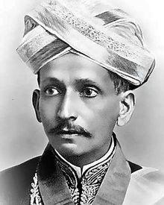

**Name:** Bharat Ratna Sir M Visvesvaraya

**Years:** 1861-1962

**Quick Facts**

* September 15th is celebrated as Engineer’s day in India in his memory
* The  Visvesvaraya Industrial and Technological Museum, a museum in Bangalore, is named in his honor.
* He designed automatic sluice gates to solve the problem of reservoir overflow
* Mahatma Gandhi constantly to praised the amazing engineering feats of Sir M Visvesvaraya.